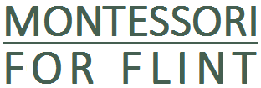
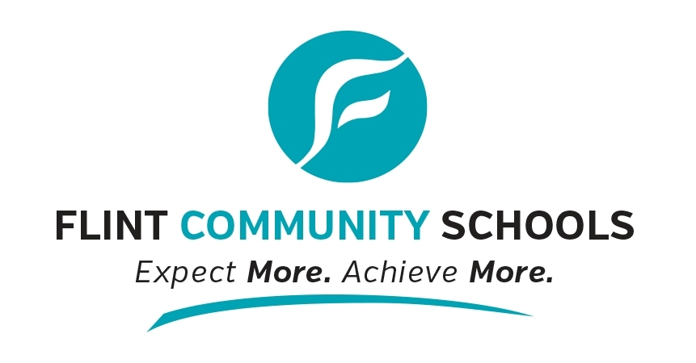
Montessori Interest Form
2016-17/2017-18

Flint Community Schools has a new Montessori program for elementary students. The class serves students in kindergarten and 1st grade in 2016-17 and will expand to kindergarten through 2nd grade in 2017-18. There are also opportunities for Montessori preschool programs. Montessori is a way of teaching where students learn:

- At their own pace and have freedom within limits.
- From each other in a multi-age classroom.
- With hands-on materials, moving from concrete to abstract concepts.
- With a teacher and classroom environment that follow kids’ natural curiosity.
2016-17 School Year
- Preschool and infant/toddler options
- Grades K-1 at Durant Tuuri Mott Elementary (next to Flint Children’s Museum)
- Maximum elementary teacher-student ratio of 17:1

2017-18 School Year
- Preschool and infant/toddler options
- Grades K-2 at Durant Tuuri Mott
- Potential to add classrooms based on demand

Children must be at least 5 years old by December 1 in order to enroll.
This program is open to Flint students and students outside the district.

Check us out at www.flintmontessori.weebly.com

and on Facebook

Knowing you are interested helps us plan well. For more information about enrollment, please contact Michelle McQueen at (810) 760-5260 or mmcqueen@flintschools.org.
------------------------------------------------------------------------------------------------------------------------

Montessori 2016-17 and 2017-18 Interest Form
Student’s Name: Click here to enter text. Birthdate: Click here to enter text.

Home Address: Click here to enter text. City: Click here to enter text. ZIP: Click here to enter text.

Phone Number: Click here to enter text. Email: Click here to enter text.

Parent/Guardian’s Name: Click here to enter text. Date: Click here to enter text.

☐I am interested in the Choose an item. school year (pick one).
☐My child will be in Choose an item. grade (pick one).
☐My child has been in a Montessori program before.
☐I want to get emails about this program from Montessori for Flint.

Please mail, email, fax or deliver this form to:
To complete enrollment, you need to provide a copy of the child’s immunization record, proof of residency, and original birth certificate at the Centralized Enrollment Office.

Flint Community Schools
Attention: Michelle McQueen
923 E. Kearsley St.
Flint, MI 48503
Fax: (810) 760-5070
Want to go paperless? Sign up online at www.flintmontessori.weebly.com
mmcqueen@flintschools.org

